Nama : Astiany Dwi Prasinta

NIM : 18090059 (5D)

**PRAKTIKUM II**

1. Source Code

Latihan1 -> Application/Controller/Latihan1.php

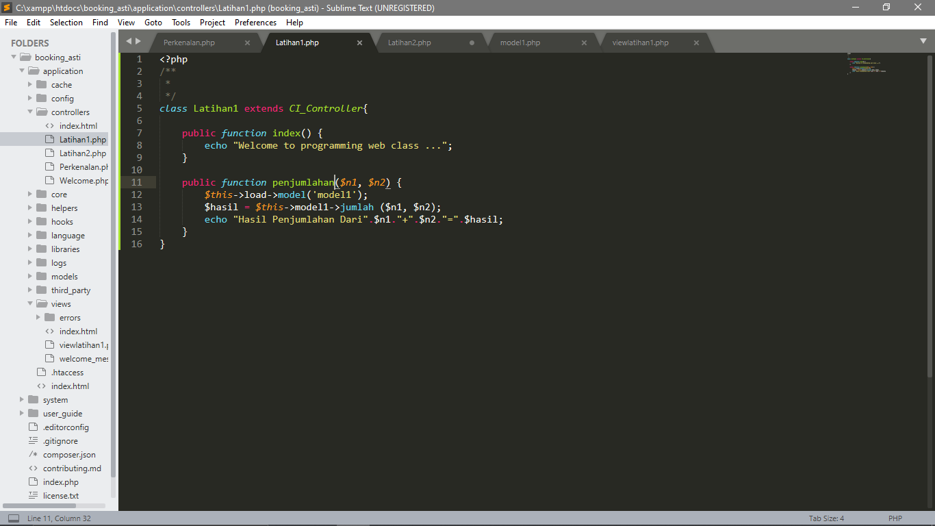

Latiahan2 -> Application/Controller/Latihan2.php

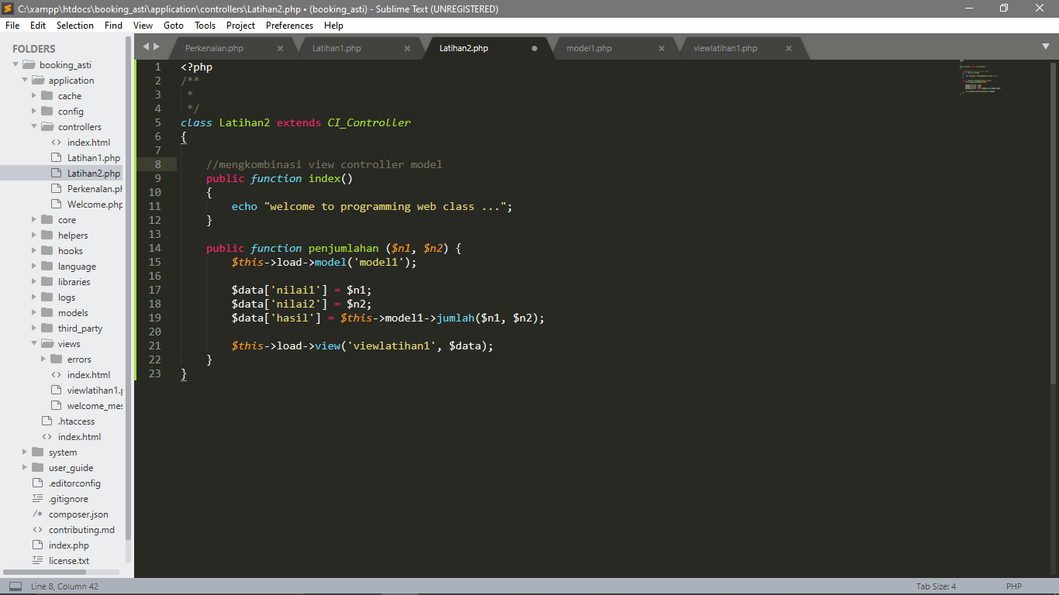

Model1 -> Application/models/model1.php

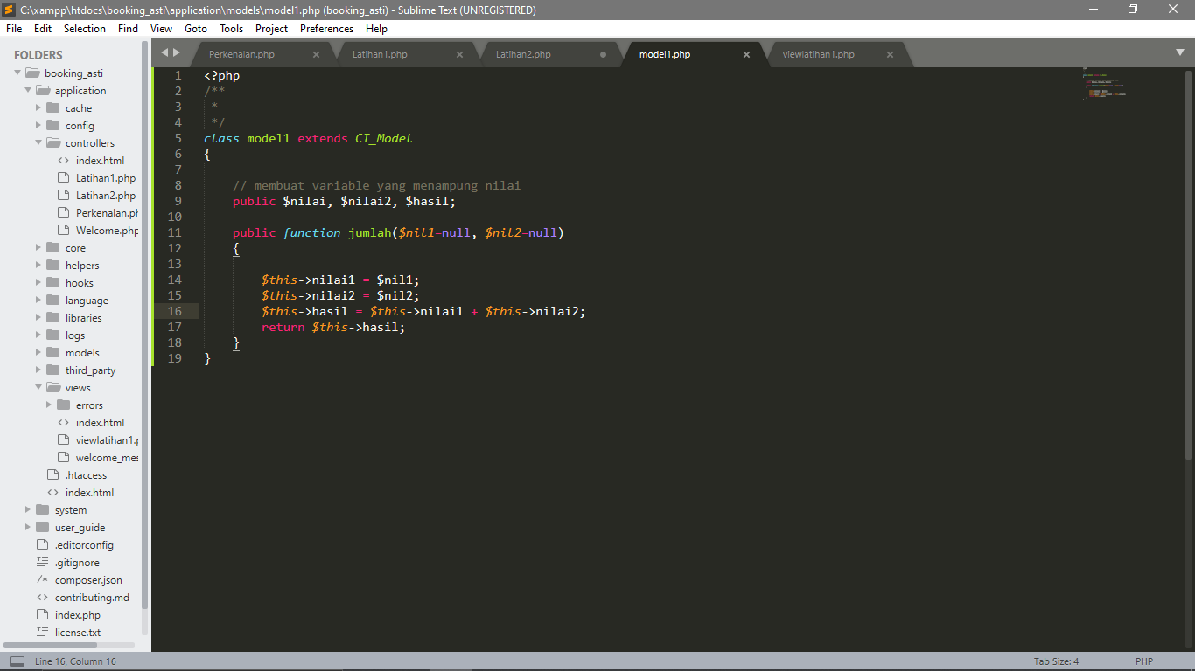

Viewlatihan1 -> Application/view/viewlatihan1.php

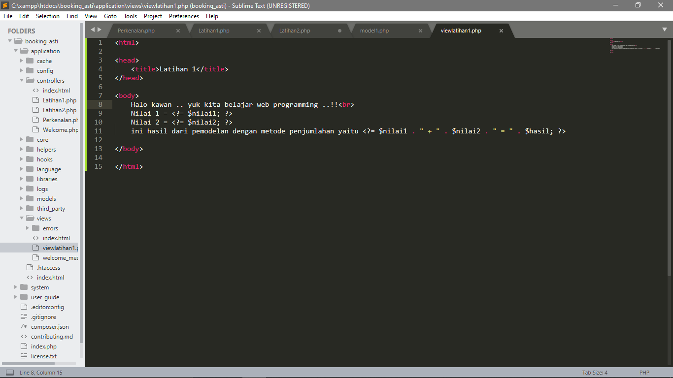

1. URL

<http://localhost/booking_asti/index.php/Latihan2>

<http://localhost/booking_asti/index.php/Latihan2/penjumlahan/7/7>

<http://localhost/booking_asti/index.php/Latihan1/penjumlahan/0/4>

1. Output

Run Latihan2

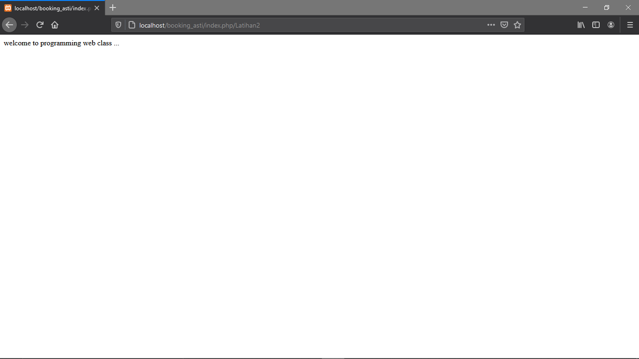

Run Latihan2/penjumlahan/7/7

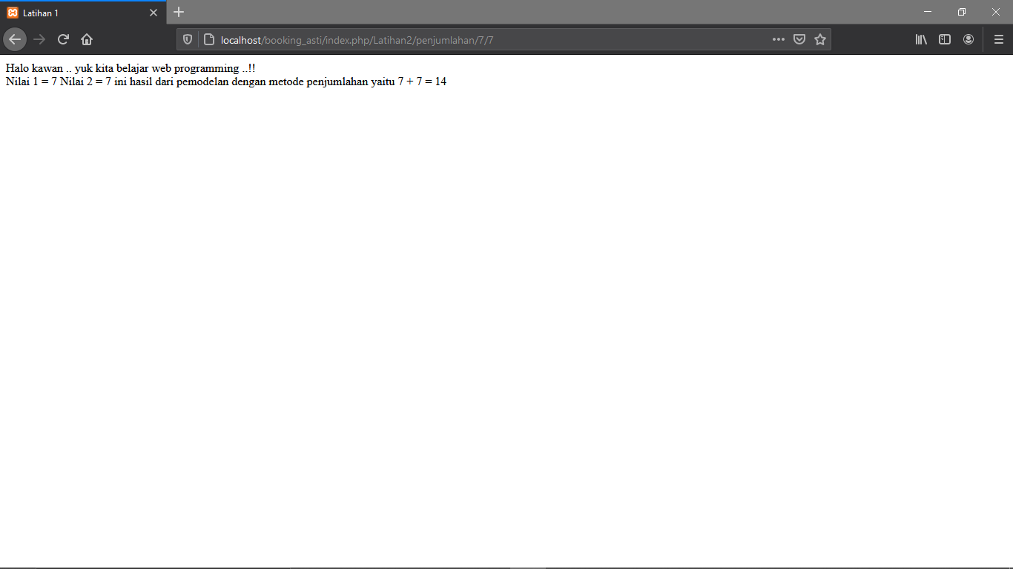

Run Latian1/penjumlahan/0/4

